Taiwan Code of Ethics for Nurses
2023 Revised Edition
A. Foreword
The fundamental responsibilities of nurses are caring for the health of individuals, families, communities, and ethnic groups (hereafter called care recipients); promoting health; preventing disease; restoring health; and alleviating suffering. Nurses are committed to the implementation of professional autonomy, evidence-based professionalism and ethical thinking in nursing care to maintain health standards and the behavioral standards of practice; enhance evidence-based professional knowledge and skills; address social and public issues; fulfill social responsibilities; practice self-discipline, autonomy, professionalism and unique style; and maintain the dignity and professional image of the nursing profession. It is with the above in mind that the Code of Ethics for Nurses has been established to define the professional behavior and responsibilities of all nurses in Taiwan.
The conceptual framework of this Code of Ethics includes the core values of nursing, ethical principles, ethical rules, professional relationship, the teamwork, workplace safety and wellbeing, concern for social issues. Furthermore, this code specifies relevant provisions for "nurses and care recipients," "nurses and practice," "nurses and the nursing profession," and "nurses and society" to serve as ethical guidelines for nurses' practice, so that nursing care meets professional standards and social expectations.

B. Conceptual Framework

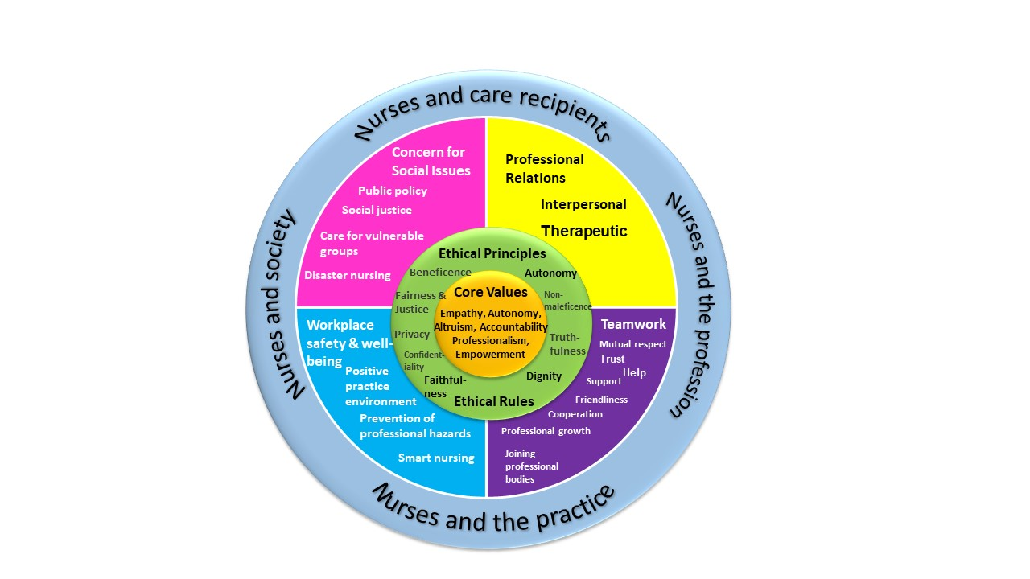
Graph: Conceptual Framework of the Code of Ethics for Nurses in Taiwan
C. Taiwan Code of Ethics for Nurses

I. Nurses and Care Recipients

- Nurses provide person-centered, safe, and evidence-based nursing care that promotes the physical, mental, and spiritual health, well-being, and quality of life of care recipients.
- Nurses approach care recipients with cultural sensitivity, respect, and acceptance, establishing open, sincere, and empathetic professional relationships with them.
- Nurses respect the individuality of care recipients, maintain their dignity throughout the nursing care process, and ensure that the care provided both meets their needs and is delivered in an effective and timely manner.
- Nurses utilize professional knowledge and the influence of professional organizations to assist in addressing health resource inequalities and promote the health and well-being of care recipients.
- Nurses listen to and respond to the needs and concerns of care recipients to ensure that their physical, mental, spiritual and social needs are appropriately met.
- Nurses collaborate with members of the healthcare team to provide care recipients with medical-related information that facilitates and respects their informed autonomous decision-making in medical matters.
- Nurses make every effort to uphold the best interests of care recipients, ensuring that the information they receive is accurate, complete, and comprehensible and that their right to accept or refuse treatment is respected.
- Nurses support the use of complementary therapies that are based in evidence-based healthcare, respecting the autonomous choices of care recipients for their benefit.
- Nurses maintain the privacy of care recipients and fulfill the duty of confidentiality.
- Nurses advocate for a patient safety culture and promptly report and take relevant measures when medical care near-miss errors or abnormalities occur.
- Nurses uphold individualized care when using technology-assisted care, respect the choices of care recipients, and ensure their comfort.
- Nurses safeguard the safety, privacy, and rights of care recipients when they consent to participate in research or clinical trials.
- Nurses provide care recipients with health and care consultation, assisting them to enhance their self-care abilities and to jointly resolve healthcare problems.
- Nurses dedicate efforts to integrating and utilizing medical and social resources, engaging in interdisciplinary team communication, coordination, and collaboration to provide comprehensive and continuous nursing care for care recipients.

II. Nurses and Practice

- Nurses engage in continuous professional development and lifelong learning to enhance professional competence and fulfill the professional responsibilities of nursing practice.
- Nurses actively empower and collaborate with nursing colleagues and other interdisciplinary professionals, providing guidance and support to nursing students and novice nurses to promote professional development.
- Nurses maintain personal physical, mental, and spiritual health to deliver high-quality and safe nursing care to care recipients.
- Nurses uphold personal professional quality and adhere to the legality of professional conduct to maintain a professional image and earn the public trust.
- Nurses practice within the legal framework and their personal abilities, applying professional judgment when accepting and delegating responsibilities, referring to relevant evidence-based knowledge and clinical guidelines, and seeking assistance as necessary.
- Nurses offer improvement suggestions for practices that lack evidence, safety, empathy, ethics, or competence, intervening or reporting to supervisors when necessary to ensure care recipients receive ethical and safe care.
- Nurses provide nursing care during disasters and infectious diseases outbreaks in accordance with regulations and guidelines provided by government authorities, employers, and professional organizations and employ appropriate safety precautions while doing so.
- Nurses support and participate in ethical research, following evidence-based and professionally recognized research ethics guidelines.
- Nurses promote the use of smart practice environments to enhance the consistency and quality of care, reduce nurses' workload, and improve work efficiency.
- Nurses foster a friendly and positive practice environment, preventing occupational hazards and workplace bullying.
- Nurses adhere to teamwork ethics, with team members respecting, trusting, supporting, helping, and cooperating with each other.
- Nurses advocate for the reasonable needs of care recipients, serving as their spokespersons and building a culture of ethical practice and effective communication to safeguard and enhance their health and well-being.
- Nurses take immediate action and report to supervisors when their own or a colleague’s health and safety are threatened, even when doing so may negatively impact professional performance or quality of care are negatively impacted.
III. Nurses and the Profession

- Nurses actively develop and practice professional core values, including empathy, autonomy, altruism, accountability, empowerment, and professionalism.
- Nurses support evidence-based clinical practice and actively participate in research-based practice development.
- Nurses actively engage in professional organizations to create a safe and socially and economically equitable environment for those engaged in clinical practice, education, research, and administrative management.
- Nurses contribute to the development of professional standards and the formulation of nursing and health policies through academic research to advance the profession.
- Nurses promote the application, dissemination, and validation of research findings related to care improvement and innovation.
- Nurses participate in teaching, mentoring, and assessing nursing students and nurses to ensure the professional continuance of nursing and to maintain quality of care.
- Nurses define the positioning of the nursing profession in various practice settings to fully utilize its roles and functions.
- Nurses promote nursing professionalism, uphold the reputation of the nursing profession, demonstrate commitment to nursing ethical standards, and become role models for others.
- Nurses join nursing professional organizations and actively participate in activities that promote the development of nursing.
- Nurses refrain from using their professional position to endorse or promote profit-driven products.

IV. Nurses and Society

- Nurses uphold the concept of social justice, assume the social responsibilities of nurses, protect the lives and health of the public, and attend to issues that influence sustainable development.

- Rooted in a global perspective and the principles of social justice, nurses exercise professional social responsibilities, promote public awareness of global healthcare issues, and take appropriate measures to prevent current issues / problems from worsening.
- Nurses take timely actions that are aligned with social needs and the health of the population to ensure the accessibility, universality, acceptability, and comprehensiveness of healthcare.
- Nurses advocate for fair resource allocation, medical care accessibility, and equality and social justice in other social and economic services.
- Nurses promote a culture of medical care safety, by identifying and analyzing potential risks to medical care, medical / healthcare settings, and public safety and health and providing recommendations for amelioration / prevention.
- Nurses conduct regular drills with interdisciplinary team members for special situations such as natural disasters, mass casualties, epidemic outbreaks, and other emergencies to enhance effective emergency response capabilities and ensure personal safety.
- Nurses collaborate with other healthcare professionals and the general public to uphold the human right to health.
- Nurses reflect the strengths of the nursing profession and promote international healthcare diplomacy to help reduce resource-based health inequities among nations.
- Nurses recognize vulnerable and marginalized groups in society, understand their unequal access to healthcare, and advocate and take actions to reduce healthcare barriers and enhance healthcare equity.
- As part of their effort to raise the positive social profile of nurses and nursing, nursing professional organizations are responsible to address social, economic, environmental, and political factors that impact upon public health, and, through collective advocacy or political action, facilitate legislation that improves the health, safety, and well-being of the population.
*Revised by the Taiwan Union of Nurses Association, June 2023
*Translated by the Taiwan Nurses Association, June 2023

